Sign Language Detection and Conversion to Text Using CNN and OpenCV
Debayan Das
19MCA0070

PROJECT GUIDE: Prof. M. Varalakshmi

School of Information Technology & Engineering (SITE)
Vellore Institute of Technology (VIT)
Vellore, Tamil Nadu, India
_______________________________________________________________________________________________________
Abstract— Computer vision has been rose as an important domain of research nowadays. With the technological trend in man-machine interfaces and the machine intelligence, these powers are used for making the life of the people easier and less complex. Communication plays an important role in our daily life, but when it comes to the area of deaf and dumb people it becomes very difficult. The only way out from this is sign language which is uninterpretable by people. This paper focuses on making an interface between the normal people and that deaf and dumb people with the help of computer vision. To do so first a classification model is built to identify the sign alphabet using CNN and then for real time application the hand gesture sign is detected using OpenCV and fed to the model to make the final prediction. And after recognition it is converted to text for further use.
Keywords— American Sign Language (ASL), Convolutional Neural Network (CNN), OpenCV, Computer Vision, Deep Learning, TensorFlow, Sign Gesture, Keras

INTRODUCTION

Sign language is one of the specific areas of human gesture communication and a complexed language that is used by the various deaf and dumb communities around the world. Unfortunately, there are very few people who are sound to sign language and it leads the deaf and dumb community to a social isolation. Motivated by this here tried to develop a system that would be able to interpret the sign language and that would be helpful for the deaf and dumb community to break all the barrier of communication with natural people without knowledge of sign language.

The field of deep learning rapidly growing in recent years and an important domain for research work. Particularly “Convolutional Neural Networks” are able to achieve a better result in terms of accuracy in the field of Image Classification. Similarly, OpenCV has become a popular open source library in terms of image processing and improving many fields of Image Processing.

In this work a combination of CNN and OpenCV is used to make an interface to make the communication easier between the deaf and dumb community and the people with no proper knowledge of sign language. In this work American Sign Language dataset is used to train the CNN model. Then the interface is made with the help of OpenCV that captures the image and makes it ready so that it can fed to the model. Then the image is fed to the CNN model and the output is displayed in the screen.
II. RELATED WORK

In one study [1] an interface is made to make the conversation easier between a normal people and the one with disabilities. For this they have used CNN model. They have trained the model with the hand gesture images and then the have deployed the model with the interface. The detects the gesture from the one with the disabilities and then convert it to text and displays it and converts into speech for both way communication.

In another study [2] an interface is created to convert sign language to text using CNN model by data augmentation technique. They images were captured by Microsoft Kinect. The images were augmented to generate more perspective views to avoid the overfitting.

In another approach [3] an alignment framework is proposed with iterative optimization. The framework have two modules: a “3D-Resnet” which is used to learn feature and “CTC” an encoder with decoder sequence learning network where two decoders (“LSTM”, “CTC”) are togetherly trained with the criterion of maximum likelihood.

In this paper [4] they propose “RGB”, “RGB-D”. These are static gesture recognition method by the use of a fine-tuned “VGG19” Model and this uses a feature concatenate layer of those images to increase the accuracy. They got 94.8% accuracy on implementing the model on American Sign Language recognition dataset.

In this work [5] a framework is proposed to interpret sign language and convert it to text. For this a CNN model is used which is trained by preprocessed hand gesture image dataset.

In this study [6] a deep neural network model is used to convert to natural language sentences from sign videos by the utilization of human keypoint extraction like face, hand and gesture recognition. For this “KETI” (Korea Electronics Technology Institute) dataset which is a sign language dataset is used. The translation model achieved 93.28% accuracy.

In another study [7] a support vector machine (SVM) based recognition is used to identify hand gestures. The model uses a function of eigen space size and features of human moments for the classification of different hand features.

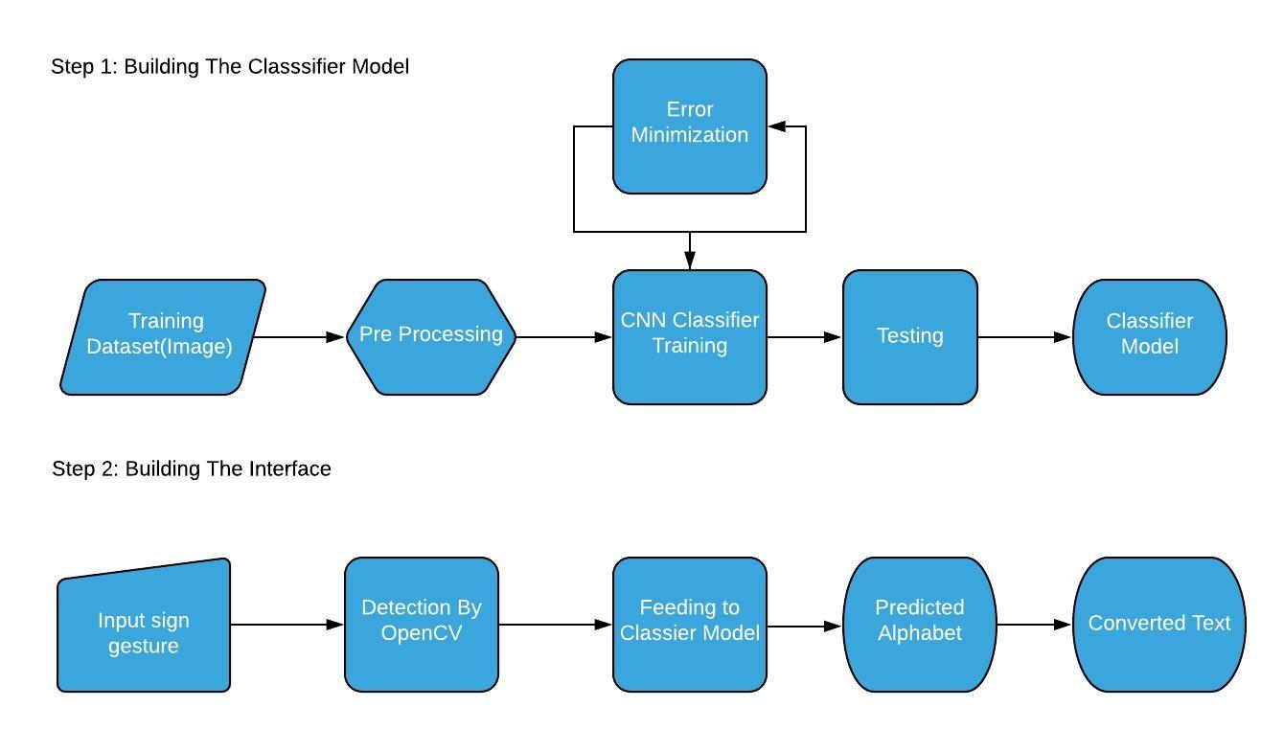
In this study [8] they have used 3D-CNN model to recognize the hand gestures and to convert them to text. They captured the images frames using OpenCV and trained the CNN model with the frames.

III. PROPOSED WORK

The proposed work actually has two steps. In the first step the classification model will be made using the collected dataset to identify sign gesture for image. And in the second step the interface will be made through which communication will be possible between the people who belong to that deaf and dumb community and the normal people.
The Picture at the bottom of the page depicts the data flow of the work.
Now the work has 3 major phases. These are data processing phase, model training phase, interface making phase
A. Data Preprocessing:
In this phase a dark background is pasted around all the images and the images are converted to ‘RGB’ format to make the image channels similar. Next all the images are transformed to similar dimension 400x400. At the end images are saved but while saving the images extension of the images are changed to .jpeg from .png. The input of this phase is the collected image dataset and output is the processed image dataset.

B. Training the CNN model:

In the second step the CNN model is trained with the images which are classified to 36 classes (A-Z and 0-9) previously. The CNN model contains total 9 layers. First two are two convolution layers followed by 1 maxpool layer. Then again two convolution layer followed by 1 maxpool layer. Then there is one flatten layer which is followed by two fully connected layer(dense). For optimizing the model “stochastic gradient descent” (SGD) method is used and the model is trained for 10 epochs. The input of the model is the preprocessed image set. And while training the model the error has been minimized as much as possible. The final result of this phase is the CNN classifier.

C. Making The Interfcae

The 3rd step is to make the interface that will interpret the sign language and will convert to text. This is made using OpenCV library of python. First the image of the palm gesture is captured using the webcam of the computer and preprocessed using the OpenCV tools so that it can be fed into the CNN model. The preprocessed image has been fed to the pretrained model. And the model predicts the class of that image and then the class is converted to respective alphabet or digit and is shown into the screen. The user or anyone can see that. The input of this phase is the captured signed gesture and the output is corresponding alphabet or image that is converted text.

IV. EXPERIMENTATION AND RESULTS
A. Dataset Description
The final dataset is an image dataset. The dataset contains 1825 images. All are in JPEG format and of pixel size 400x400. The images are palm images representing various alphabets of ASL. The below image specifies various sign gestures.
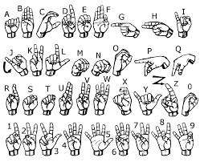
The dataset is collected from Kaggle Datasets. And the dataset was previously labeled into 36 classes. 26 alphabets(A-Z) and 10 digits(0-9).
B. Classification
The model gives almost 99% accuracy while predicting. And the interface is quite stable enough which can detect gesture in an interval of 30 miliseconds. It can print the detected character in console and screen.
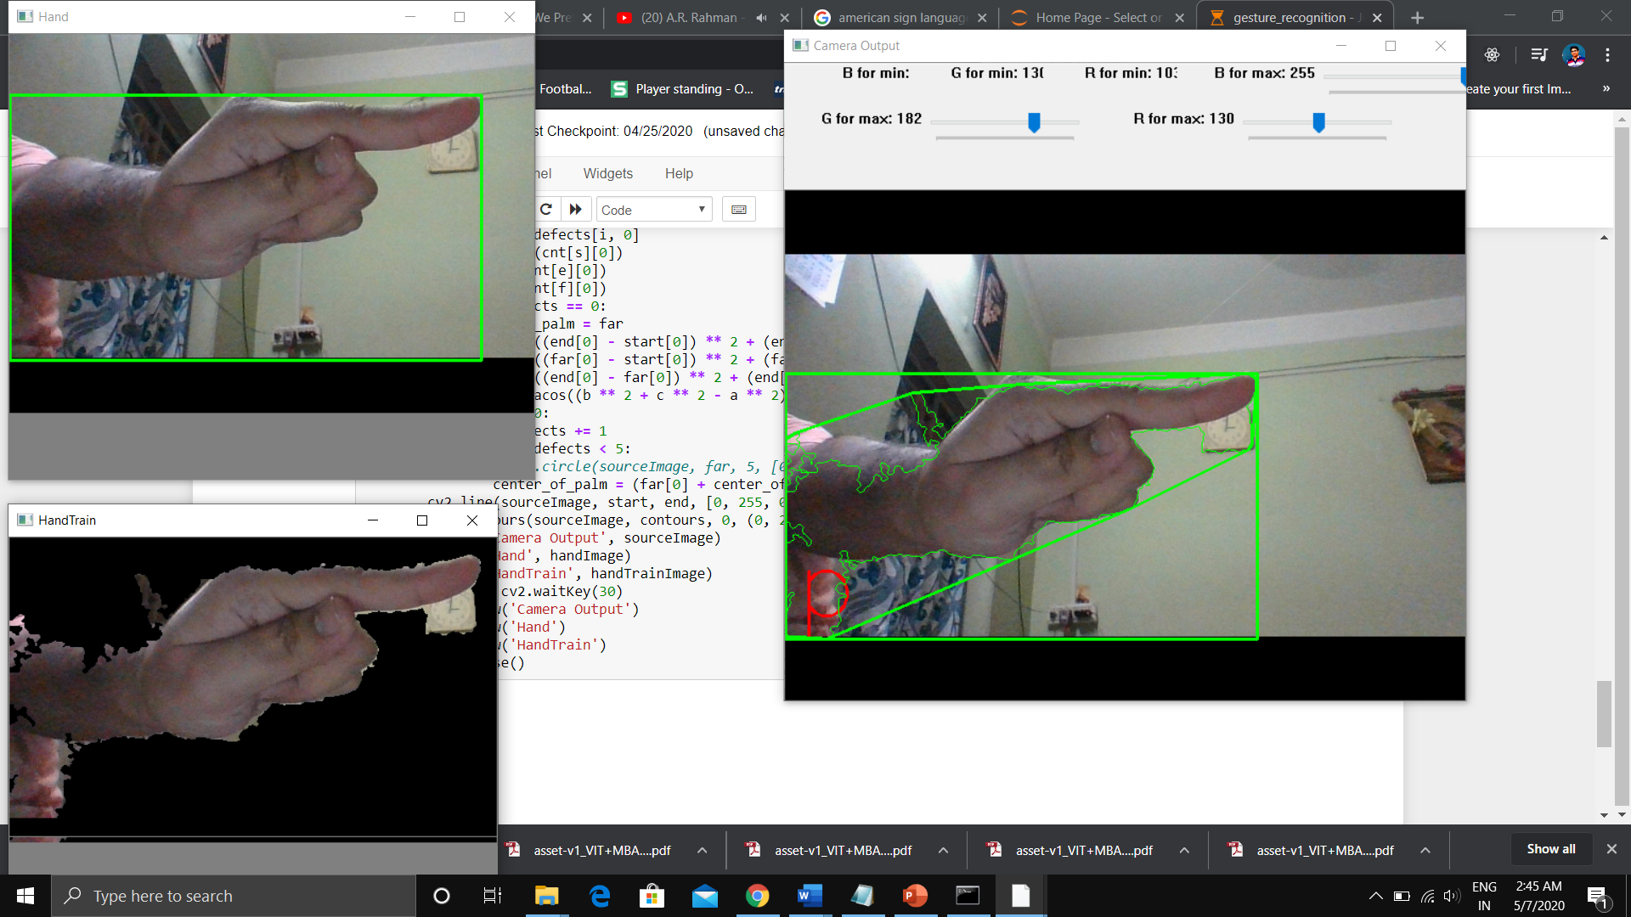
Here we can see that the model is detecting the hand image and converting it to letter ‘P’ and displaying in the screen.

V. CONCLUSION

In the previous works that are done on sign gesture recognition some have used CNN and some have used OpenCV. The problem was with CNN, we can acquire a high level of accuracy but only with CNN the work was not a real time approach. On the other hand, in the use of OpenCV the system is becoming real time but accuracy level is less. In this work the feature of both those has been tried to combine so that system becomes real time and the accuracy level remains high. This system can be used in the medical, educational and many other fields. We will be very happy if the system comes in use of society and people. In the next versions we will try to make the system more accurate and stable than this version and will try to add other features like convert the text to some other language based on the choice of the user and converting the text to speech and we will try build an android version of the system. The work is done on limited resources so we will be happy if anyone try to build the system using more powerful resources to make the system more accurate.
VI. REFRENCE

- Jose, D. A. A. R. D., & Davis, J. (2019). Sign Language Translator Using CNN Model.
- Tao, W., Leu, M. C., & Yin, Z. (2018). American Sign Language alphabet recognition using Convolutional Neural Networks with multiview augmentation and inference fusion. Engineering Applications of Artificial Intelligence, 76, 202-213.
- Pu, J., Zhou, W., & Li, H. (2019). Iterative alignment network for continuous sign language recognition. In Proceedings of the IEEE Conference on Computer Vision and Pattern Recognition (pp. 4165-4174).
- Khari, M., Garg, A. K., Crespo, R. G., & Verdú, E. (2019). Gesture Recognition of RGB and RGB-D Static Images Using Convolutional Neural Networks. International Journal of Interactive Multimedia & Artificial Intelligence, 5(7).
- Ghaste, P. V., Bastwade, M. S., Khandelwal, R., Ambapkar, S., Ansari, Z., & Salaria, C. S. (2019). Sign Language Interpretation and Conversion to Text (September 2019). National Journal of Computer and Applied Science, 2(3), 10-13.
- Ko, S. K., Kim, C. J., Jung, H., & Cho, C. (2019). Neural sign language translation based on human keypoint estimation. Applied Sciences, 9(13), 2683.
- Kelly, D., McDonald, J., & Markham, C. (2010). A person independent system for recognition of hand postures used in sign language. Pattern Recognition Letters, 31(11), 1359-1368.
- Ismunandar, A. A. Recognizing Sign Languages Using Pattern Recognition.
- Chollet, F. (2015). keras.
- Bradski, G. (2000). The OpenCV Library. Dr. Dobb&#39;s Journal of Software Tools.

